**QR Code Generator**

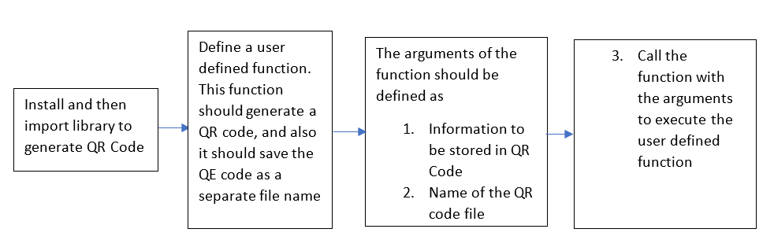

| **Steps** | **Description** |
| --- | --- |
| Step 1 | Install the library qrcode using “pip install qrcode” |
| Step 2 | Import library to generate QR Code |
| Step 3 | Define a function to generate QR code using the library, and to save the generated QR code as a separate file |
| Step 4 | Define two variables: Then store the information (<https://www.amazon.com>) to be embed into QR code in one variable , and the file name of QR code in the other variable |
| Step 5 | Call the function with two arguments. Two arguments are two variables:  First variable = information to be stored in QR code (https://www.amazon.com) Second variable: File name of the QR code. |
| Step 6 | Run the program to generate the QR code |